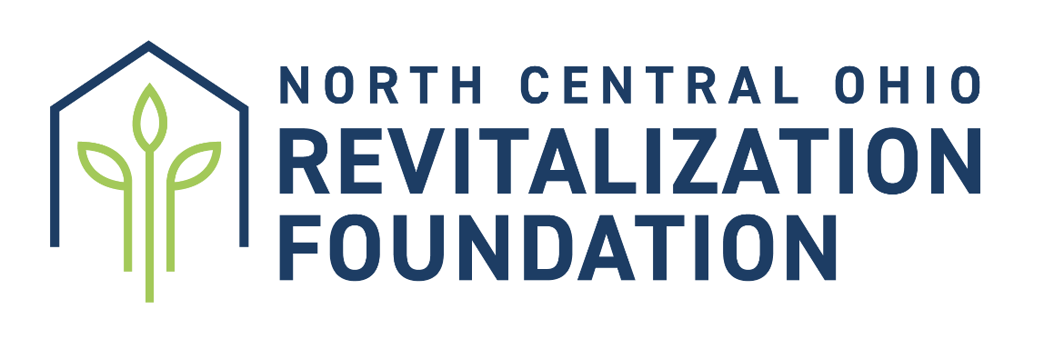

**REVITALIZE GRANT REQUEST FORM**

Thank you for your interest in a grant from the NCO Revitalization Foundation. These funds are used specifically to assist local established churches in revitalizing ministries in their context and community so that individuals find the hope of Jesus for their lives.

The Revitalize Grant is a partnership grant that can be used to provide *up to 50%* of the total cost of a ministry, training, or improvement that will help the local church experience new direction and energy as they seek to tell others of the love of Jesus.   It is important that each church understands that the Revitalization Foundation will only consider requests that show how 50% of the total cost will be raised by the local church.  Although the grant can be used for several things, greater attention is given to how these funds will impact individuals in discovering who Jesus is.   
  
*Please note that if approved the Revitalization Foundation may assign a coach to assist your church in moving forward with the request and to aid in successful completion of the Ministry/Training or Improvement you are requesting.

**The Revitalize Grant can be used to:**

Strengthen a growing ministry that is outpacing the income

Assist with building improvements for greater ministry

Supply Leadership Training and Development

Seed Evangelism Resources to tell others about Jesus

Fund a brand-new ministry to meet a need   
**Max amount that can be request for 2025 is $9,400.**

**Revitalize Grant Requirements: (Deadline is June 1 Annually)**  
1. Church Board Vote Recording the Date and Result of the Vote and the Ballots Cast  
2. Successful Completion of the Church Health Assessment Tool on District Website (This can include a church review within the last year)  
3. Number of salvations and baptisms for the current year.

4. Church Financials

End of year financials reported in the Annual Pastors Report (APR) will be considered by the foundation  
 This information will be pulled directly from the APR itself so there is no need to include it

5. Detailed Budget of Ministry/Training or Improvement

Provide a detailed budget of expenses

Provide a specific plan for how 50% of the funds will be provided by the local church

6. What is your church’s current evangelism strategy?/When applicable, please also share how this request fits your overall evangelism strategy.

7. Explanation of Plan and Potential Results

List in detail the plan for the Ministry/Training or Improvement

Explain the prayerful expected result of the grant fulfillment

8. List how the grant can cause resurgence and excitement to the church now.

What would this grant do for the emotional state of your church?

How could this grant be an answer to prayer?

9. Proper Reporting to the Foundation

When the Ministry/Training/Improvement is complete, provide a detailed report to the Foundation within 60 days of completion. The Foundation must receive a report before May 31st in the church year funds were disbursed. The report must include fund accounting/people reach/impact on community and church.   
*Failure to report may impact future requests.  
*Funds should be used for stated purpose and any deviation should be communicated to the Revitalization Foundation ahead of time, or the funds returned to the foundation.

How does your church apply?

Use this form as a guide to provide the necessary information. Print and mail this form to: NCO Revitalization Fund, 602 Martinsburg Rd., Mount Vernon, OH, 43050. Or email directly to: nco.district@mvnu.edu. Email must include all supported documentation as attachments that are listed in the grant requirements. The deadline for submitting your plan is June 1, annually for announcement in July annually at District Assembly. Funds must be used for the assembly year in which you are applying. Feel free to use extra pages if necessary and answer all that apply. If something doesn’t fit your context, please document why it does not.

*Please note: The number of grants and amount of grants may vary each year. The foundation will evaluate each grant based on information, merit, and thorough planning.*



**REVITALIZE GRANT REQUEST**

**Church/Ministry Name:** Click or tap here to enter text.

**Year:** Click or tap here to enter text.

**Accountable Person:** Click or tap here to enter text.

**Email:** Click or tap here to enter text.

**Cell Number:** Click or tap here to enter text.

**Is texting okay if there are questions? Yes or No**

**Type of Grant Request:**

Current Ministry

Building Improvement

Leadership Training

Evangelism

New Ministry

**Provide a short summary (short paragraph) of what you plan to do with the funds:**

Click or tap here to enter text.

**Amount Requested:**Click or tap here to enter text.

**1. Board Vote**Date of the Church Board Vote:  
Result of the Church Vote:   
Ballots Cast:

**2. SUCCESSFUL COMPLETION OF CHURCH HEALTH ASSESSMENT TOOL**Please note when the tool was completed and how many board members participated  
Provide the total score average of all responses.   
Note any discussion the church board has a result of the tool and what plans, if any were established.  
Click or tap here to enter text.

**3. CHURCH FINANCIALS**

Year end financials will be pulled directly from your reported APR, no need to include.   
If there is something you would like us to know in relation to your church financials you may list it below.

Click or tap here to enter text.

**4. DETAILED BUDGET OF MINISTRY/TRAINING/IMPROVEMENT**

Provide the detailed budget below. You can import your excel spreadsheet or attach/email it separately.

Give attention to indicating how your church plans to raise 50% of the funds.

Click or tap here to enter text.

**5. EXPLANATION OF PLAN AND POTENTIAL RESULTS**

What will the grant be used for?

What is the expected outcome of the use of these funds? (Changed lives, new attendees, community connections, etc.)

How do you plan to follow up? (List the details below)

Click or tap here to enter text.

**6. LIST HOW THE GRANT CAN CAUSE RESURGENCE AND EXCITEMENT TO THE CHURCH NOW**

What would this grant do for the emotional state of your church? How could this grant be an answer to prayer?

What will change in your church because of this grant?

Click or tap here to enter text.

**7. PROPER REPORTING TO THE FOUNDATION**

Once the Ministry/Training/Improvement is complete, provide a detailed report to Foundation within 60 days

The report must include fund accounting/people reach/impact on community and church.

Questions for you to answer:

What were the results of the ministry/evangelistic event?

Click or tap here to enter text.

How many lives were impacted?

Click or tap here to enter text.

How has follow up happened?

Click or tap here to enter text.

Any personal story of transformation you could share?

Click or tap here to enter text.

Provide financial records showing how the dollars were spent.

Click or tap here to enter text.

The financial report needs to be in printed form. The balance of the report can be provided in print form or in short video form showing the ministry that was conducted with the funds. This video does not have to be professionally done. The quality you would get from a smartphone would be sufficient. *(At minimum, please ensure that photos are taken of the event to share with the district.)* Please email all report information to: [nco.district@mvnu.edu](mailto:nco.district@mvnu.edu)  
  
  
  
__________________________________ ___________________________________  
Church Board Secretary Signature Pastor’s Signature